(Approx. 1,647 words)

Photodex ProShow Review
By Tom Ekvall, Northeast Wisconsin PC User Group newsletter editor
www.newpcug.org
tekvall(at)new.rr.com

Obtained from APCUG with the author's permission for publication by APCUG member groups.

I love creating – and watching—photo slideshows, also known as photo montages or video montages.

They are exciting as photos and video clips are set to music with special effects and sounds added to the production. Memories no longer need to be kept in photo albums or shoeboxes. The slideshows can also be burned onto a DVD or CD, shared by email or uploaded to a web site, or even kept as a screen saver.

I remember many years ago my dad used to take plenty of slides with his Nikon camera and would put together slide shows (real slides) of his trips, camping outings, and other occasions that all of us would watch. He even did travelogues that he showed to senior groups and others of his trips complete with two slide projectors, a dissolve unit, tape recorder and all the equipment to put on a first class production. He did slideshows of Civil War battlefields, the Smoky Mountains and other popular sites.

Slideshows must have become a family interest as my sister who lives near Denver also enjoys putting together photo montages on DVD of her vacation trips for others using a Macintosh computer. ProShow will not work, though, with the Mac Operating System; however, it can be used with success on those newer Intel-based Macintosh computers with a program such as Boot Camp that allows Macs to run Windows-based products.
Today there are plenty of software on the market for producing slideshows ranging from free ones through Microsoft with simple effects to ProShow by Photodex Corporation of Austin, Texas, that represents to me the “tops in class” of anything available.

Slideshows can be done as part of photo editing programs, created through video editing software that allows adding photos to a video production, or as a stand-alone product.
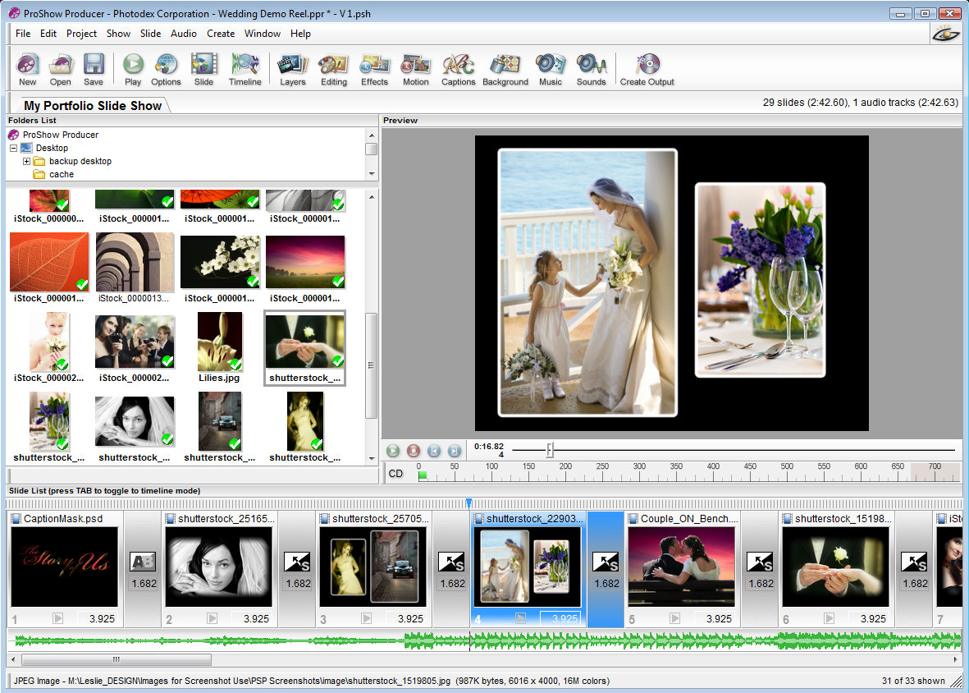
I tried out a number of slideshow products and feature for feature, nothing can compare with ProShow, especially the Producer version targeted at professionals who want the ultimate in what a slideshow can deliver ($249.95). The company also offers a ProShow Gold version ($69.95) aimed at photo enthusiasts that packs a wallop in creating simply amazing shows. The price is for download versions; add $20 for download plus box version of Producer and $10 for Gold.
The Gold version offers many of the features of the Producer model and both outshine any other product I have seen. There is also a Standard Version for under $29.95, but I would opt for no less than the Gold version. The latest version is 3.2 with upgrades available free for 12 months.

What the ProShow products offer is the ability to fully customize any aspect of the production from beginning to end.

The product is available only through Photodex, either as a download or as a box version. The company also has a first-class support service for unlimited free help, including that for a trial version good for 15 days that you can download. I called in with a question that was immediately resolved. The company is dedicated to providing the highest quality service. I cannot think of few other sites that provide free technical support to trial version customers. My only complaint about the trial versions is that while fully functional, the output bears a strip across the middle of the slides noting that the photo show was created on trial software. By purchasing the product you receive a registration code that will eliminate the strip. Support help is available seven days a week by phone or by email.

I installed the Producer version of the product on a HP laptop computer running Windows Vista Home Premium with an AMD Turion 64 dual core processor and 1 gigabyte of RAM. No problems with the installation and everything set up perfectly. I was able to produce my first slideshow without reading instructions, attesting to the simplicity of the product while offering many customization tools that add a “WOW” factor to the production. The product will also run on Windows XP. The Producer version requires at least 1 gigabyte of RAM and a 1 gigahertz processor. The Gold version will run on Windows ME or 98 and can get by with 512 megabytes of RAM.
My first show was one featuring the college liaison person for the Northeast Wisconsin PC User Group which meets at the Fox Valley Technical College. He has been a longtime member and is also an avid balloonist and attends the computer and electronic shows in Las Vegas. We collected pictures of him and of the user group over the years, which I then used to create a DVD show. I had most of the presentation done early had brought my camera to our January meeting, at which time I took pictures of him talking about the Consumer Electronics Shows. Within minutes, the pictures were downloaded into the show, set to music and a DVD created in a manner of minutes presented to him as a surprise.

I found the rendering speed of the final product to be very fast to create the final product.

There are numerous features about the program (both Producer and Gold versions) I like which make it a must have. These include:
- The ability to add background music simply playing an audio CD on the computer and importing a track directly into the program; a show can also be created whereby the photos will automatically sync with the length of the music or link specific photos to specific tracks. I did a wedding show in which the wedding music began as the bride walked down the aisle (my wife). There were 150 photos and four sound tracks in the 15-minute production. I also did a one-click audio sync to a family Christmas show timing the photos (and transitions) to the length of a Christmas song recorded by my wife’s cousin, who records children’s music.
- Over 280 transition effects (much more than I could ever want, although it does not pay to put too many in a show without it becoming a distraction. The transitions can be set as to time length or set automatically for the show duration.
- Probably the best I have seen in motion effects (the pan and zoom or “Ken Burns” effect) for a slideshow program with the ability to do precise controls modifying many different aspects of each slide
- Layering capabilities that allow unlimited layers on any slide that can create amazing effects. With the Producer version, you can add video clips onto a still photo slide
- Masking and keyframing opportunities with layer opacity control on the Producer version only that enhance the layering effects as to motion with the slides with precise control
- Supports more than 100 input file types and can output to ipods, cell phones, Zunes, YouTube, and other portable devices; Producer version also supports RAW photos
- DVD burner support included with both Gold and Producer
- Video clips can be added to the show with both versions while video can be added as a layer in the Producer version
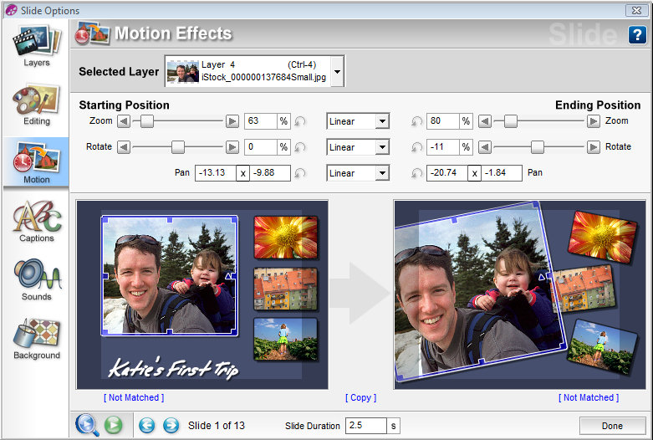
Other features of note include unlimited undo’s, photo editing capabilities, multiple captions and text that can be animated to one or more slides, real time preview, drag and drop rearranging of slides, the ability to customize the background, built-in audio and video trimmers.
Tutorials are available through the company’s website (www.photodex.com) as well as three DVDs through the company that cover layering, keyframing and audio controls ($49.95 each). There are several user groups that I joined through Yahoo groups dealing with Proshow and the Producer version, where users offer comments about the product and its features and upload shows for others to critique. I get numerous posts each day from group members.
For photo professionals and others in the corporate world, the Producer version offers the ability to allow viewers to interact with the presentation on a computer, such as enabling the person to access a particular web site or other information, pause the presentation, or interact in other ways. A great tool for real estate professionals who may want to showcase their properties or lead them to links of places and information of interest. The Producer version also allows optional watermarking to protect the photos in the show.

The one thing the product does not have that I could determine is the ability to print pictures from the produced show, which may be an issue for someone wanting to share pictures with other for them to print out if desired.

In summary, this is a fantastic program. Either the Gold or Producer version will provide a professional tool to create exciting slideshows that you and others can enjoy. Producing a slideshow takes only a short time and the wide variety of control options enhances the creativity you can put into the show. If you are hooked on creating slideshows, I would opt for the Producer version even if you are only a photo enthusiast based on the added features, such as keyframing, masking, and timing controls. Settings can also be saved for creating future shows.

The slideshows so far produced were simple and basic, but very entertaining. Next month I will review in the newsletter the more dramatic effects that can be created such as keyframing, layering, and masking and training tutorials available from the company to create these effects. After watching videos produced by others on the ProShow user group sites, I can attest to the amazing things that can be done with a collection of photos.

This article has been provided to APCUG by the author solely for publication by APCUG member groups. All other uses require the permission of the author (see e-mail address above).

